**Capstone Project**

**Table of Contents:**

* Introduction
* Ask phase
* Prepare phase
* Process phase
* Analyze phase
* Share phase
* Act Phase

**Objectives:**

The analysis that we are going to perform shall answer the following questions:

* How many restaurants in Bangalore take online orders?
* What percentage of restaurants offer table booking facilities?
* What was the most common rating received by restaurants?
* Which cuisine do customers like the most?
* What is the average price for two people, based on the type of service?
* Does the restaurant’s rating depend on whether it accepts online orders?

**1.Introduction:**

*About the Company*:

Zomato is an Indian Multinational Restaurant aggregator and food delivery

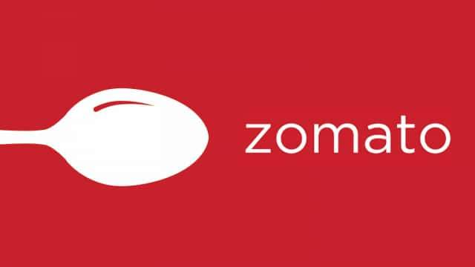 Company. It was founded by Deepinder Goyal and

Pankaj Chaddah in 2008. Zomato provides information,

menus and user-reviews of restaurants as well as food

delivery options from partner restaurants in more than

1,000 Indian cities and towns, as of 2022-23.

With the Rise of meal delivery services, everyone can now enjoy their favourite food from the comfort of their own home. Gaint food aggregators and food shipping companies like Zomato have made it feasible. Zomato is one of India’s most extensively used services for ordering food, searching restaurants.

Today, we will investigate a dataset that carries approximate facts about the restaurant chains in Bangalore that also run on Zomato.

**2. Ask Phase:**

*Business Task:*

I really get fascinated by good quality food being served in the restaurants and

Would like to help community find best cuisines around their area. To analyse how zomato is

different from its competitors.

**3. Prepare Phase:**

*About the Dataset*:

I have downloaded the Zomato Dataset from Kaggle. The Dataset is a collection of

Restaurants that are registered on Zomato in Bangalore City. In this dataset, we have 4999 Rows

and 14 Columns. The Attributes in the dataset are as follows.

**Address:**Address of the restaurant.

**Name*:*** Name of the restaurant

**Online_orders*:*** It tell that if the restaurant takes online orders or not.

**Book_table:** It tells whether the restaurants offers table reservation or not.

**Rates:** The restaurant’s rating out of 5.

**Votes:**Number of votes received by the restaurant on Zomato.

**Location*:*** the place where the restaurant is located.

**Rest_type:** specifies the type of restaurant .

**Dish_liked:** indicates whether dishes were popular among customers in that restaurant.

**Cuisines:** Cuisines available at the restaurant.

**Approx_cost(for tow people):** Estimated cost of food in that restaurant for two people.

**Menu_item:** The restaurant’s Menu.

**Listed_in(type):** Tells the type of service provided by a restaurant.

**Listed_in(city):**  The restaurant is in the city’s list.

*Tools used:*

**Excel :** used for Cleaning the data.

**Python :** used for cleaning and analysing the data.

**Tableau:** used for Visualization.

**4. Process Phase:**

Data Processing involves the following,

*# Importing the required libraries*

**

*# Importing the dataset to python*



*# Previewing the dataset*

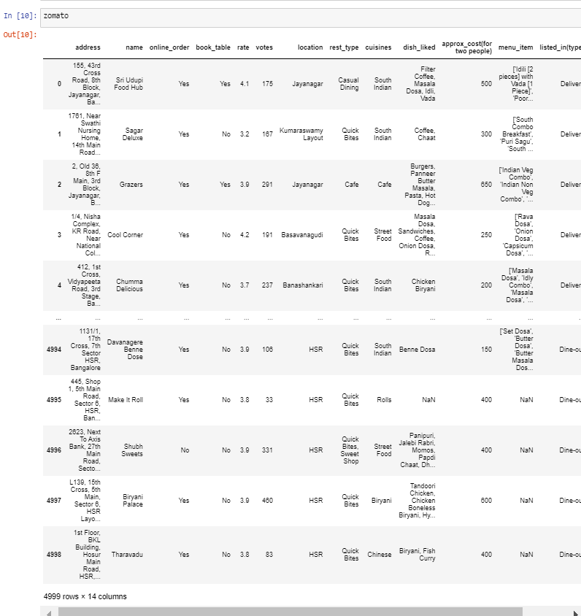

*# Checking info*

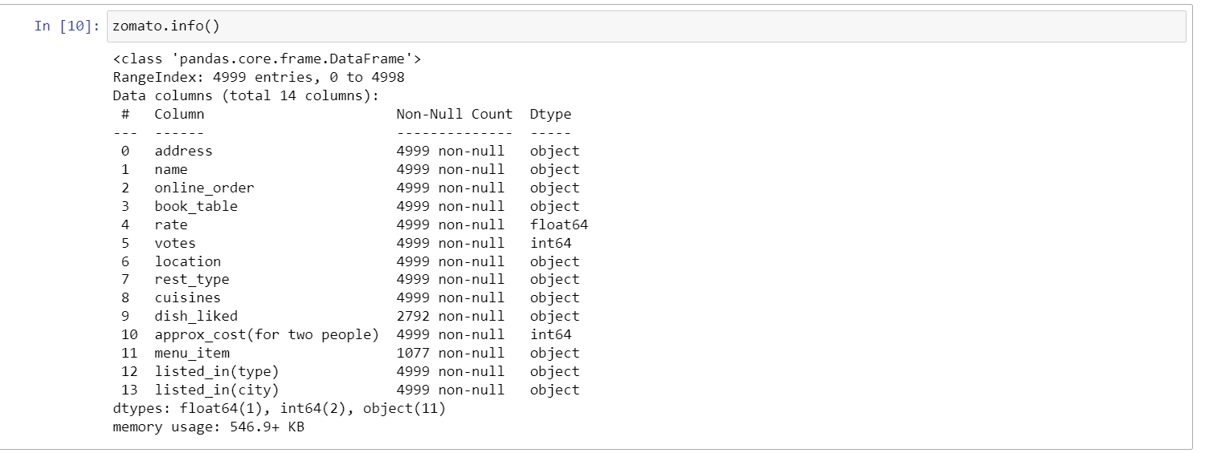

*# Checking for null using heatmap*

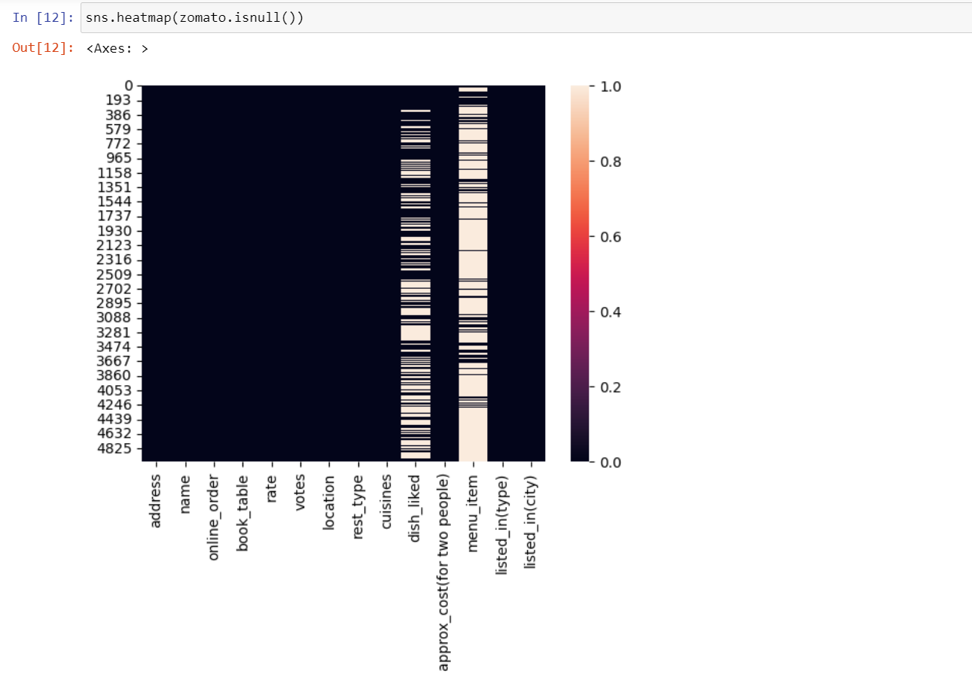

*# Dropping the columns as it contains 80% of the null values*

After looking the dataset info and heatmap, there are 80% of the nulls in the columns named dish_liked, menu_items.



*# Checking null values after dropping the columns*

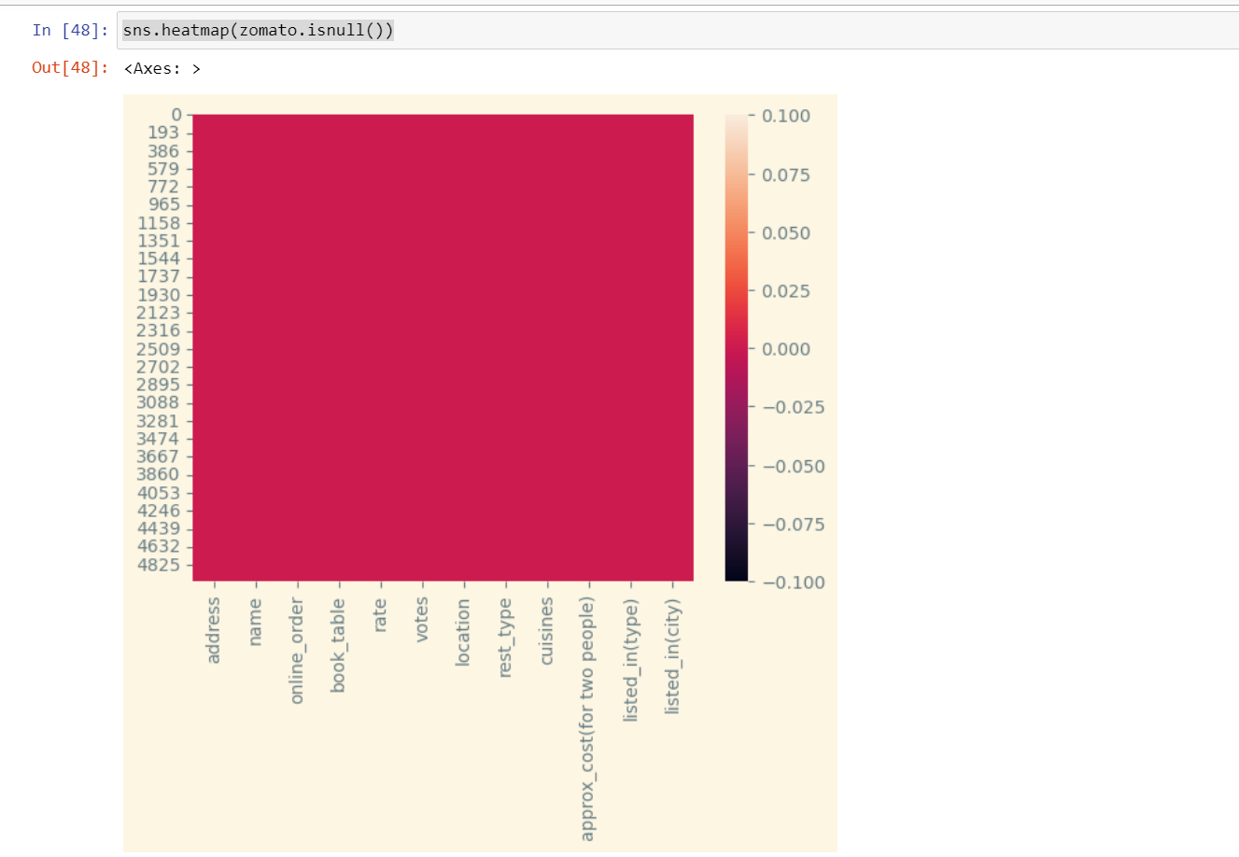

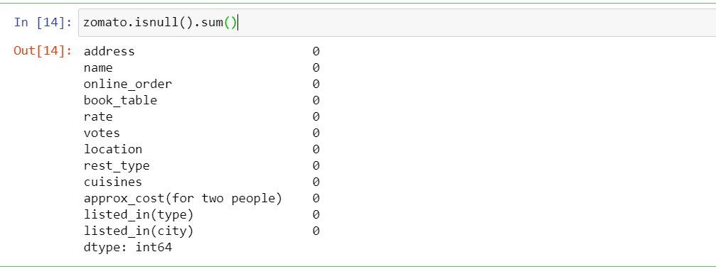

As there are no nulls and the data is cleaned. Now proceeding to Analysing of the data.

**5. Analyze Phase:**

*# Previewing the first 6 rows using head()*

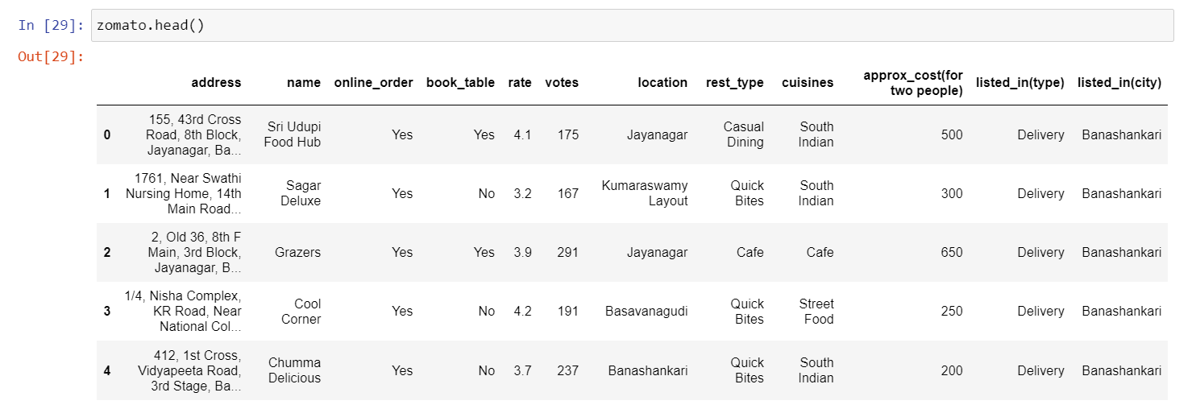

*# Describing the dataset 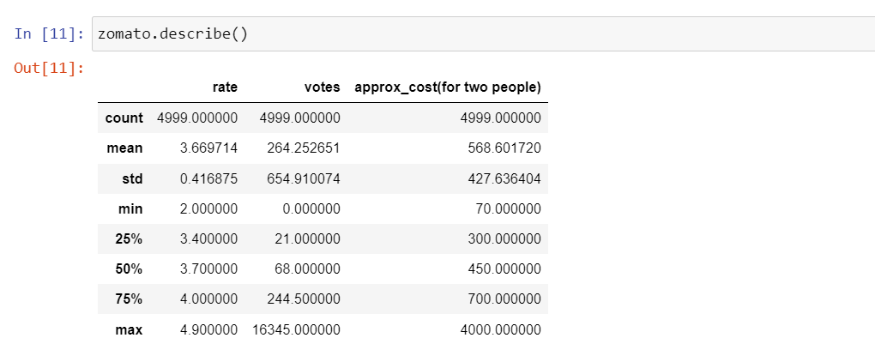*

*# Information of the dataset* 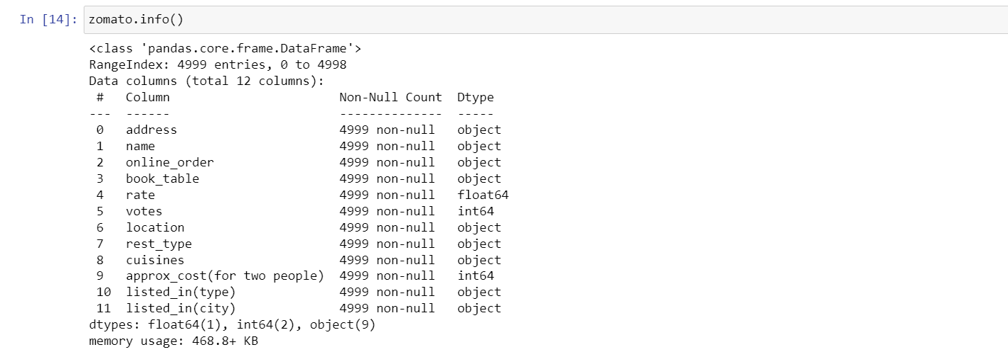

*# Sorting the rows according to ratings*

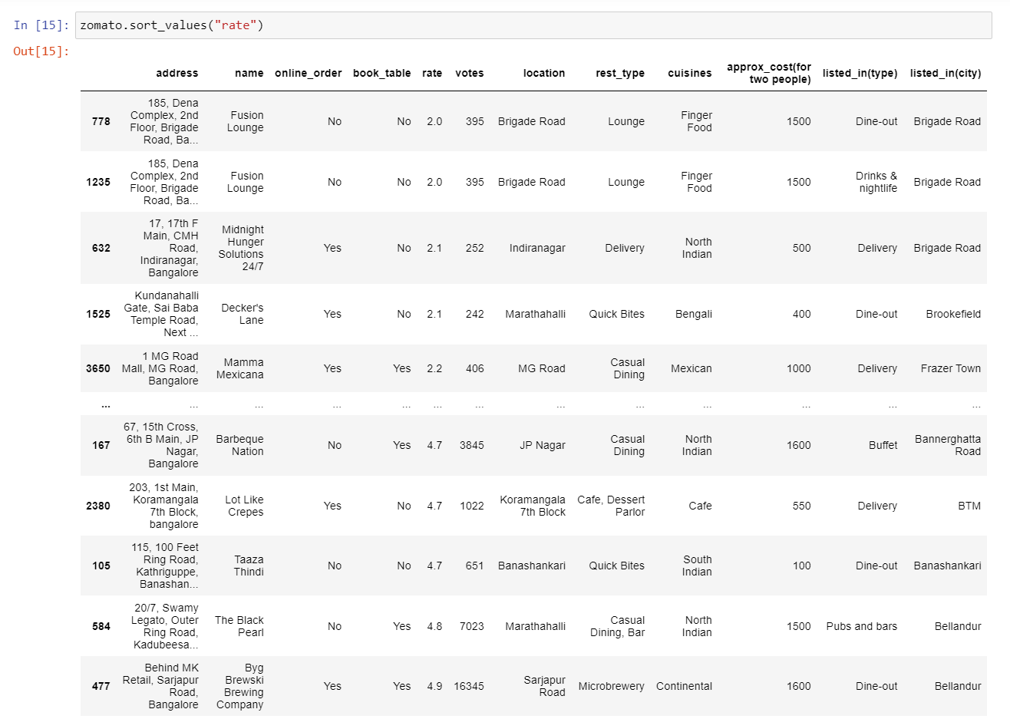

*# Count for each rating 1 to 5*

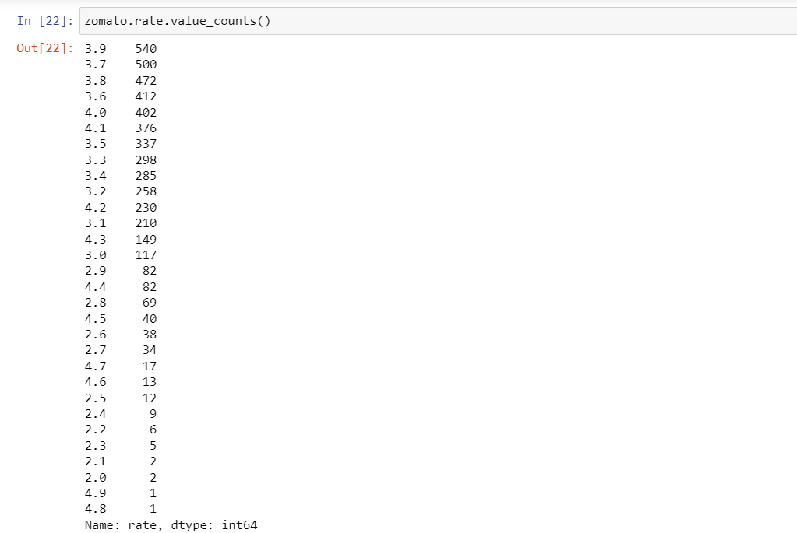

*# filtering the column of rating where rating greater than or equal to 4.0*

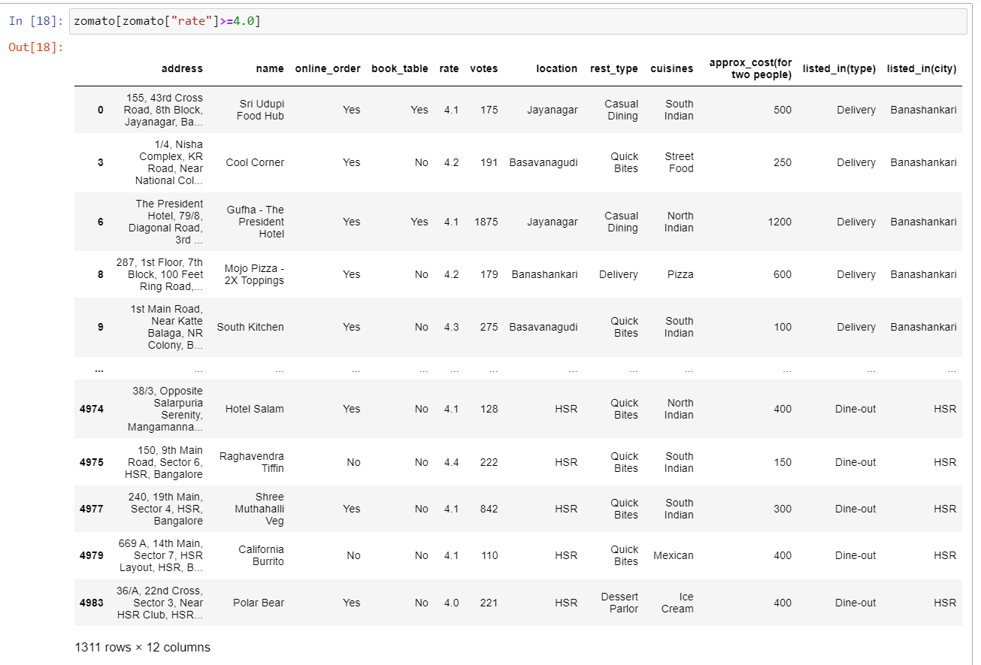

*# Unique locations in the location Attribute*

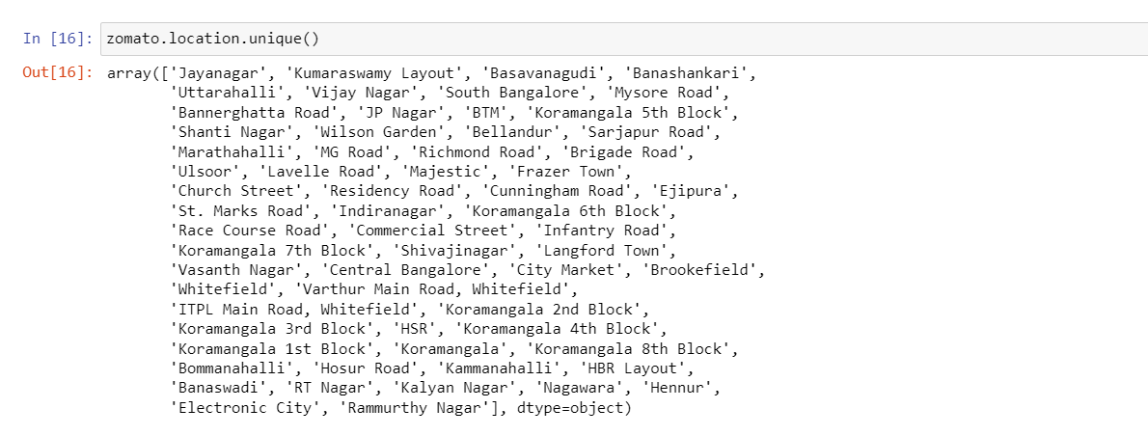

*# Count of each Restaurant names*

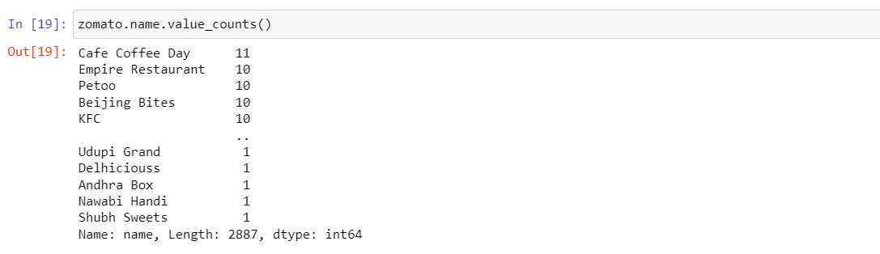

*# Count of each Cuisines in the restaurants*

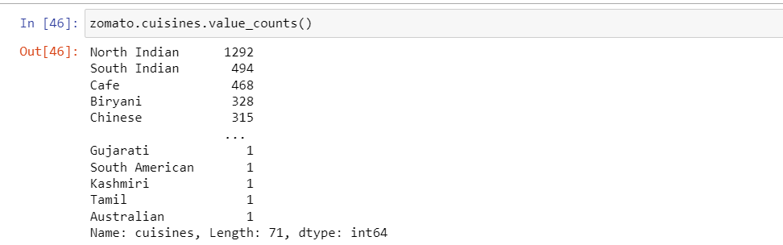

*# Correlation*

**

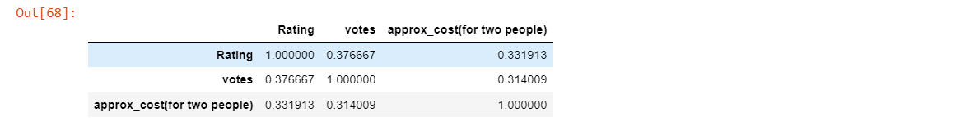

*# filtering the column which provides delivery services*

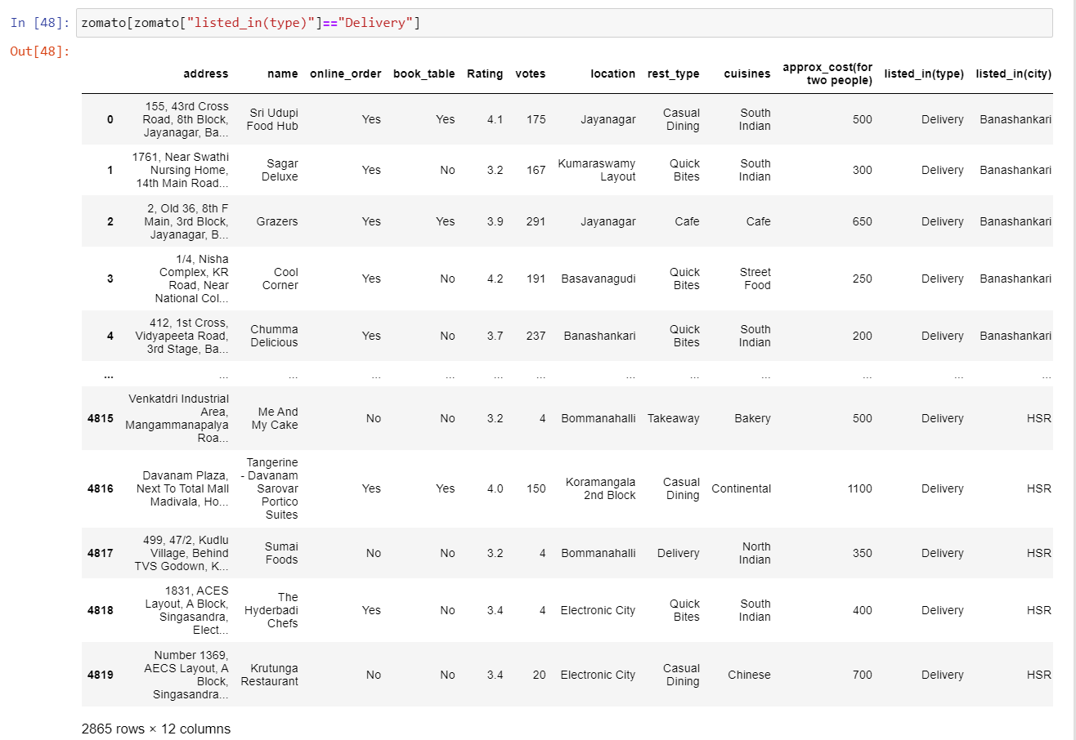

**6. Share Phase**

*Insights and Visualization:*

*1. Percentage of restaurants offers Online orders*

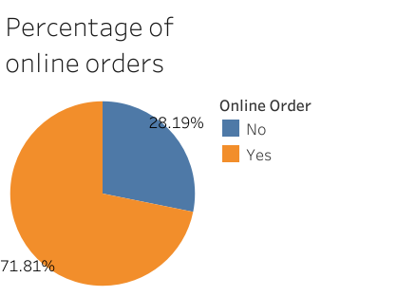

The above Pie chart shows that approximately 71.81% of the restaurants in Bangalore provides Online orders and 28% of the restaurants are not providing Online orders. To improve orders restaurants has to provide more online orders.

*2. Count of Ratings*

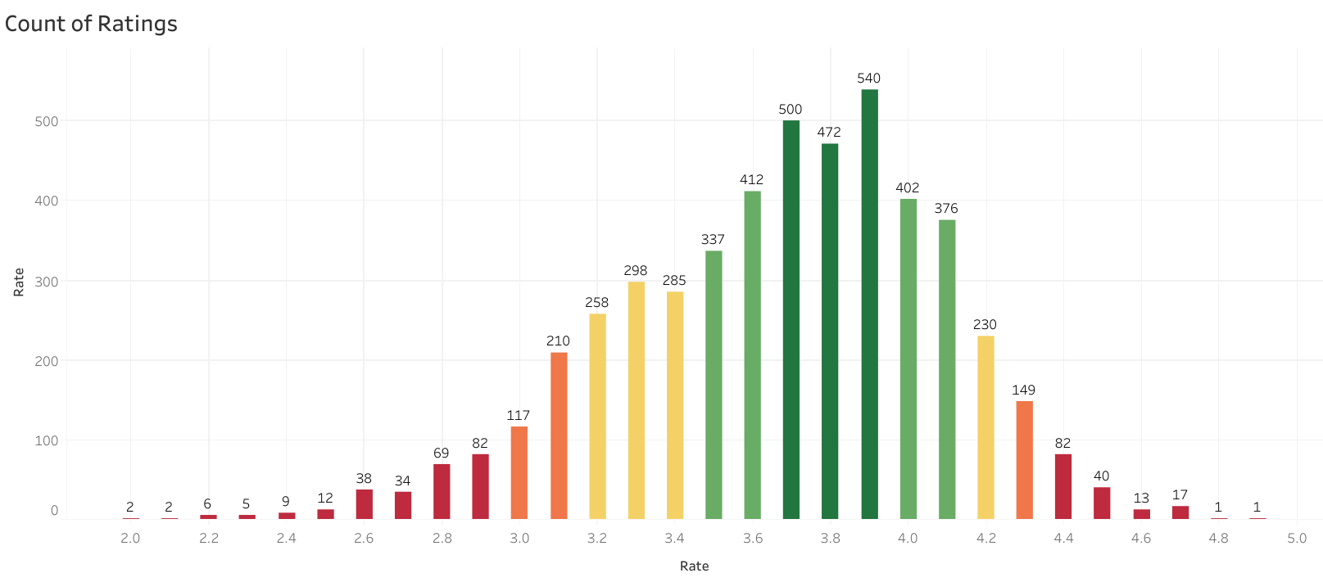

Most of the Restaurants in Bangalore received a rating of 3.8 to 3.9. Very few restaurants receive poor ratings. and only one restaurant received 4.9 rating. The most common rating is 3.9 for overall rating from 1 to 5 for restaurants.

*3. Count of Restaurants of Table bookings*

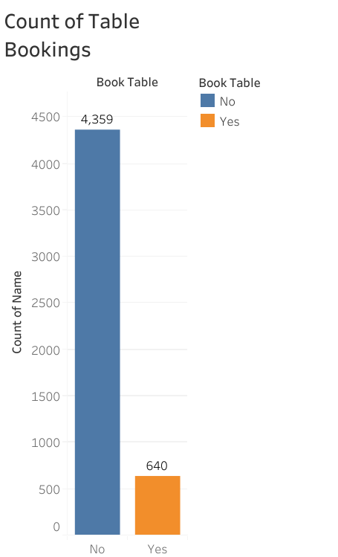

The above Bar Graph shows that Count of Restaurants names which provides Table Booking Facility. 4,359 Restaurants are providing Table booking facility and 640 restaurants are not providing table booking facility. Restaurants which provide table booking facilities have the highest rating.

*4. Rating based on Approx_cost(for two people)*

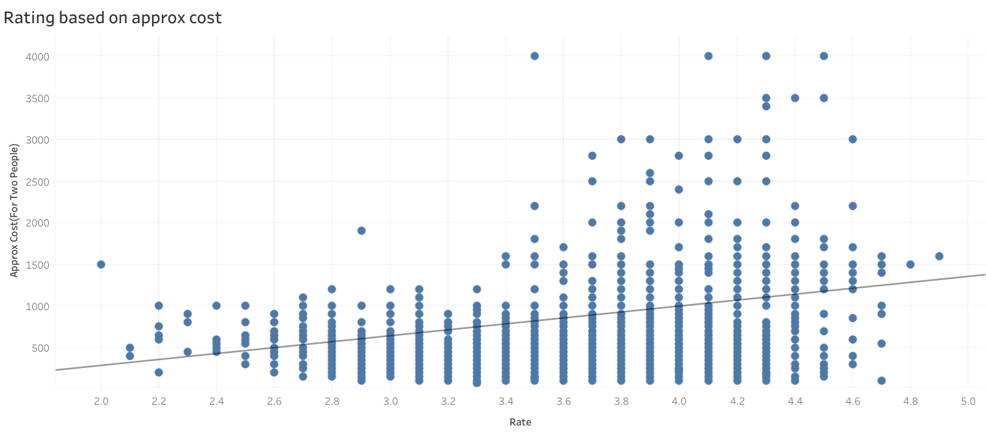

As we can see that, Restaurants that provide better quality food and variety of foods have high rating based on approximate cost. We can tell that even if the cost is high, people are enjoying that food and giving rating because of quality and variety of foods in that restaurants.

*5. Count of Restaurants for each City*

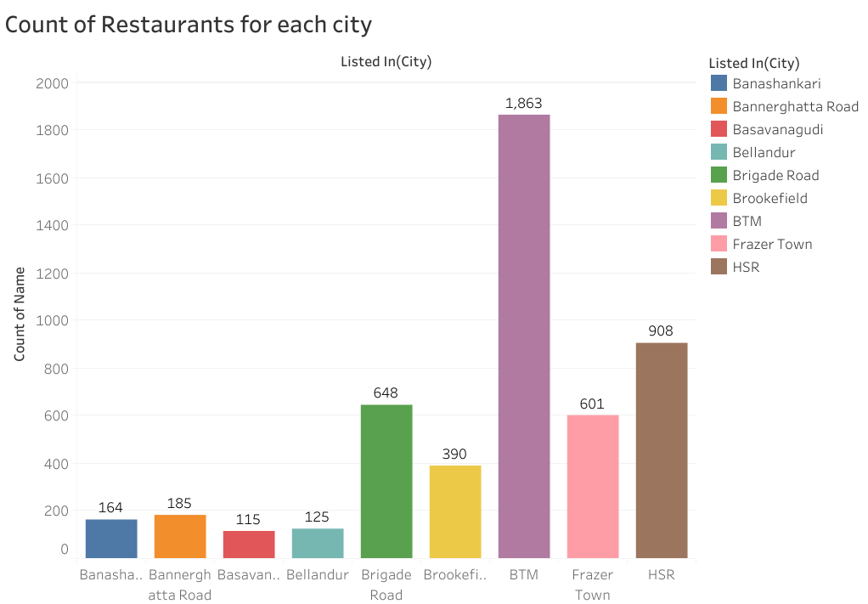

The City named BTM has the highest number of Restaurants i.e., 1,863. Has this the largest city in Bangalore which has more restaurants than other Cities. Basavanagudi is the city which has least number of restaurants when compared to other Cities.

*6. Services provided by Restaurants for approx_cost(for two people)*

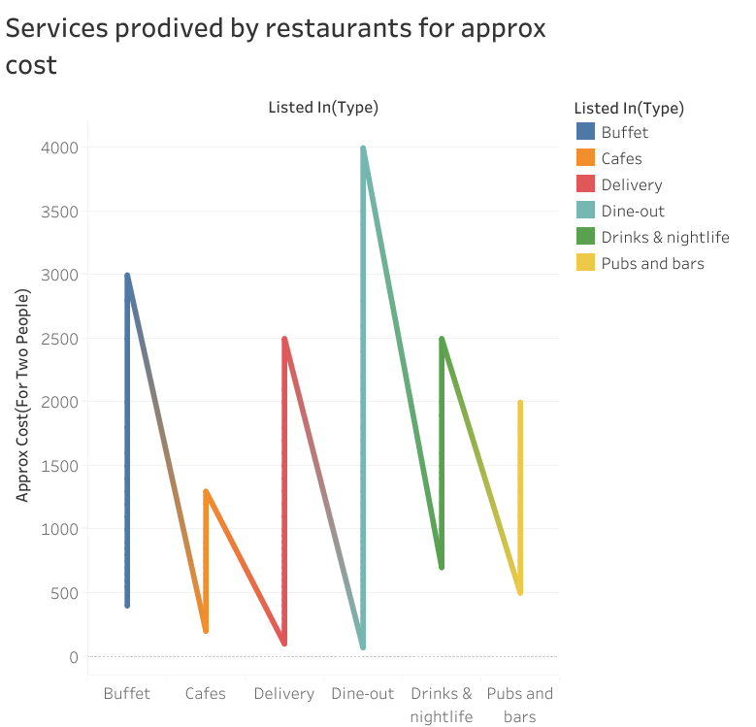

According to the line graph, Dine-out is the service which is providing least and more expensive type of food in some restaurants when compared to other services. Pubs and bars are starting with expensive cost in some Restaurants.

**7. Act Phase**

***Conclusion:***

Here, I performed exploratory analysis on the Zomato Bangalore

Restaurants dataset and looked into the most influencing factors that led to a restaurant

successful running in the city. The code, insights and visualizations provided here can

be easily understood and used to implement EDA on other similar datasets.

***Key Takeaways:***

* Restaurant ratings are highly influenced by the restaurant’s cuisine, facilities, and pricing.
* The locality where the restaurant is situated also helps in predicting whether the restaurant will run successfully or not.
* Places that sell desserts, beverages, and food delivery services tend to be the most popular among the customers.